Snow day work for Year 1 08/03/23

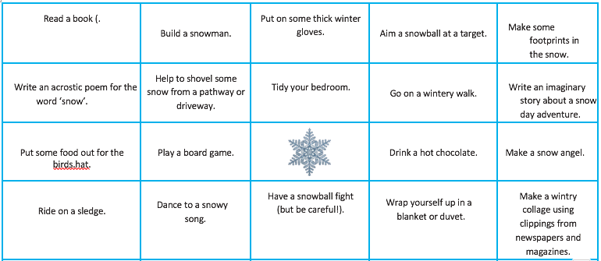

Maths: – Spend 20 minutes playing on your Doodle Maths account.

Reading: https://parents.fft.org.uk/viewer/?pdf=S53_Clever_Crows&d=Clever%20Crows
Please read with your adult and see if you can answer the questions at the back of the book. Remember to use evidence from the text.

Literacy:

If you want to stay indoors, you can use the story map attached, to help you retell and act out the story of Jack and the Beanstalk…..you could add in your changes to the story to help you with your writing tomorrow
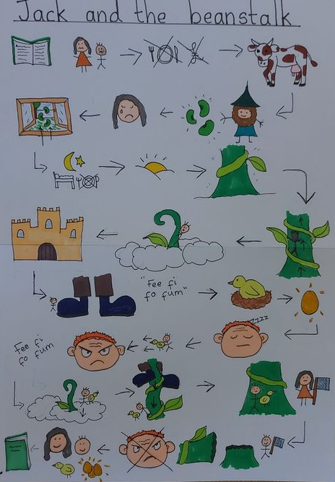

You could enjoy watching: T he alternative Jack and The beanstalk stories again…..

Jack and the Jelly Beantstalk..from 17 seconds

Trust Me, Jack's Beanstalk Stinks

……..to help with writing our own stories tomorrow.

Phonics:
Watch https://youtu.be/Wot5CmStKlY (Mr Thorn Does Phonics – the Alternative ow for /oa/ sound (Ow like in Snow)………can you have a go at writing some other words where the ow makes the /oa/ sound.

Music – enjoy singing along with Mrs Howell

See you all tomorrow

