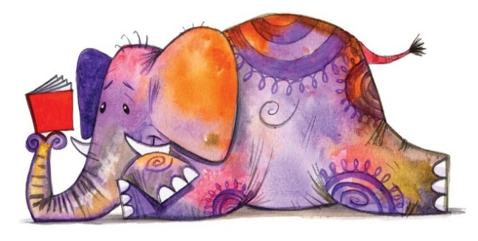
Book Week 2023 India
February 20th-February 24th
Dear Parents
We are very excited to announce that we have planned a Book Week for this term! Our aim is to encourage everyone…children and adults to… read for pleasure.
This is our first Book Week for some time and we are looking forward to an exciting week.

The theme is “We LOVE reading!” Look out for our reading song on the school website!
We would like the children to start thinking about Book Week during half term and take part in a competition called “Extreme Reading!” To enter the competition the children need to think of somewhere unusual to read a book, the more unusual the better. All you need to do is take a photo of the reading in action and bring it to school during book week in the form of a photo. The photos will be displayed and there will be prizes for the most inventive and unusual entries in each class.
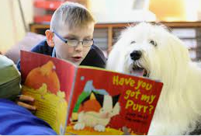
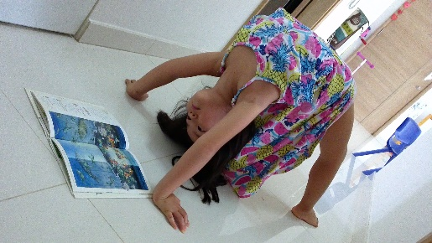

On Monday, to launch the week, we are celebrating WORLD BOOK DAY (a week early as next week is Assessment week) so we want all the staff and children to dress up as their favourite story book character. It would be great if they can bring along their book as well to share with others.
We are very lucky to have 2 of our parents, Mrs Lawson and Ms Davies, who will be leading sessions to teach the children about book editing and books for the blind on Wednesday and Thursday, respectively.
On Friday we will be having a Bedtime story day so everyone will, of course, need to come to school in their pyjamas!

During the week there will be storytelling groups all around the school which will be led by teachers, support staff and hopefully parents and governors who will all be reading their favourite stories to small groups of children. If you want to support with this then please let us know. There will also be a Library quiz for all the children to take part in.
Throughout the week we will have “STOP, DROP and READ” sessions-when we hear the bell we will all enjoy a reading sessions which could be individual or a class story.
BOOK FAIR- there will be a Book fair in each school from Tuesday to Friday so children will be able to use their World book Day tokens to buy a new book. The Book Fair will be open for business after school for children and parents to come and visit.
At the end of the week we will be sharing and celebrating what the children have learnt in a final assembly.
Thank you for your support
Mrs Bousfield

