Year Group | 2
Term | Summer 1
Subject | DT
Topic | Textiles
Curriculum Intent | Textiles –  Can I join textiles together to create a fabric bunting?

Key Vocabulary | Textiles, materials, cotton, denim, binka, hessian, embroidery needle, thread, running stitch, join, fabric, design, evaluate, scissors, template, chalk, bunting, party

skills | Cutting, sewing – running stitch, following a template, designing, evaluating, choosing materials

 | Knowledge |  | - Choose materials suitable for purpose – bunting  - Design a product – fabric bunting  - Measure, cut and join textiles in different ways  - Use a range of equipment to perform practical tasks such as cutting, shaping joining and finishing  - Evaluate my work  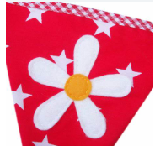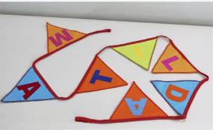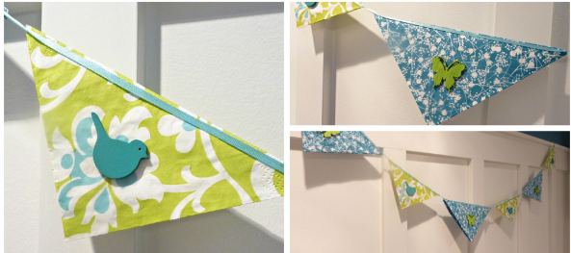  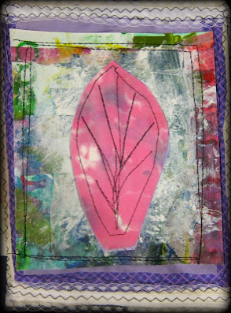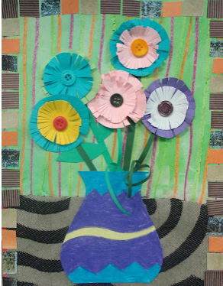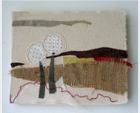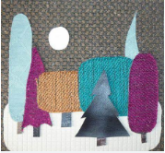
Summer 1 MTP
Week |  | Learning Objective |  | Activities | Differentiation | Outcome
1 |  | I can explore fabrics and find the use of bunting. |  | Explore and evaluate a range of existing products in the context of exploring fabrics and fabric bunting.  Children handle lots of different materials and experience a range of fabric collage  Look at how the materials are joined / fixed in different ways  Show examples of textile artists and their work – what do the children like/dislike?  What do we use bunting for? A party, celebrations, festivals – to decorate a place/ outside. Which theme could we use for our bunting so that it is a class project to decorate the classroom or outside in the hub? |  | Children have an understanding of how different types fabrics are joined in different ways to create a collage image.
2 |  | I can join fabrics together and attach different materials.  I can use a running stitch to join fabric. |  | Skills based – joining materials  Children practise joining materials together using running stitch  Teach children how to thread darning needle, make knot in thread and sew using running stitch. |  | Children can join materials using running stitch.
3 |  | I can design my bunting flag. |  | Children design simple flower / leaf / nature bunting flag – look at examples – class theme to be decided.  Children consider how each element will be joined – including gluing and running stitch sewing.  Children choose the background material which they will use as a base – felt, cotton, binka?  Can I think of ideas and plan what to do next?  Can I choose the best tools and materials? Can I give reasons why? |  | Children have a clear simple design with elements of sewing and gluing.
4 |  | I can use a paper template to help cut out a fabric shape for my bunting flag. |  | Skills based - Cutting materials.  Children use a template to cut their bunting flag shape – remember how will this be joined to the overall product of class bunting? Will we use string? Ribbon? Which material will form the base of our bunting?  Children use their design to create additional simple templates to draw round with chalk on materials and help cut out elements. Eg circle for the sun, triangle for mountains, different coloured material for land/sea, leaf shapes, petal shapes. |  | Children can use a template to help when cutting shapes in different materials ready to add to their collage.
5 |  | I can select fabrics that are suitable for decorating my bunting.  I can join fabrics. |  | Children continue to assemble fabric collage – using running stitch and glue, cutting shapes using templates. |  | Children new skills to create their product.
6 |  | I can select fabrics that are suitable for decorating my bunting.  I can join fabrics.  I can evaluate my work. |  | Children finish collage and evaluate work.  Can I describe what went well? What could I do differently next time? Which part of my work am I proud of? |  | Children produce a piece of work joining materials in different ways and evaluate skills.

