Year Group | 2
Term | Spring 2
Subject | ART
Topic | Expressive Painting (Accessart)
Curriculum Intent | To enable children to explore expressive use of paint. This includes exploring colour, colour mixing and intention behind mark making. ARTISTS: Marela Zacarías, Charlie French, Vincent Van Gogh, Cezanne

Key Vocabulary | Primary and secondary colours, expressive, artist, sketchbook, hues, abstract, still life, brush marks, impasto and sgraffito, intuitive, palette

skills | - To see how artists, contemporary and old masters, sometimes use paint in an expressive, loose way to create paintings full of life and colour.  - To start to share my response to the work of other artists.  - To use my sketchbook to fill full of colour and brush marks, inspired by other artists.  - To recognise primary colours and mix secondary colours. I can experiment with hues by changing the amount of primary colours I add.  - To use various home- made tools to apply paint in abstract patterns and be inventive.  - To make a loose drawing from a still life.  - To see colours and shapes in the still life.  - To use my gestural mark making with paint, and incorporate the colours and shapes in the still life to make an expressive painting.  - To share my experiments and final piece with others and share what I liked and what went well.  - To enjoy the work of my classmates and I can see how all the work is different. I can share my response to some of their work.  - To take a photograph of my final piece, thinking about focus and lighting.

 | Knowledge |  | - That artists sometimes use loose, gestural brush marks to create expressive painting.  - Expressive painting can be representational or more abstract.  - Artists use impasto and sgraffito to give texture to the painting.  - Artists sometimes use colour intuitively and in an exploratory manner.  - That we can enjoy, and respond to, the way paint and colour exist on the page.
Spring 1 MTP

Resources:Cameras, soft pencils, handwriting pens, a selection of ‘found tools’ such as old shoe brushes, string, wire, rags, thick strips of card, cardboard (for pallets), acrylic or ready mixed paint, a selection of bright still life objects eg plastic blocks, cups, balls, colourful mugs etc, cartridge paper.
Week |  | Learning Objective |  | Activities | Differentiation | Outcome
1 |  | To see how artists Marela Zacarías & Charlie French use paint 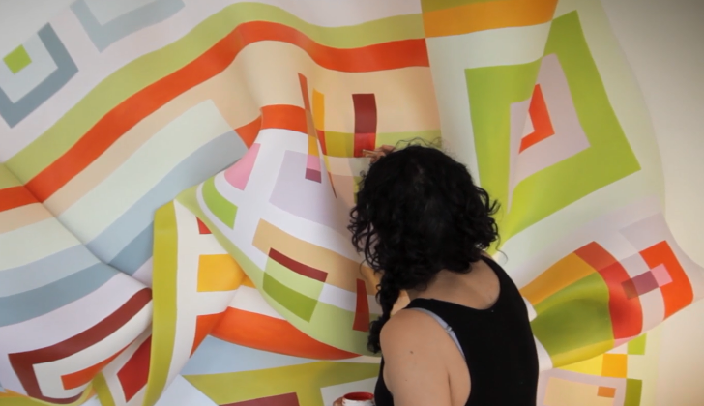  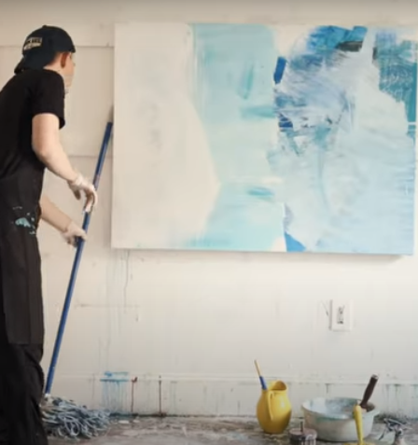 |  | Use the “Talking Points: Marela Zacarías” resource and the “Talking Points: Charlie French” resource.  Use the questions on the resources to help guide a class discussion to explore the different ways artists might use colour and mark making to make art.  Have sketchbooks open and make time during the exploration for “Making Visual Notes“ They might for example use colour to note down the colours in the artists work, or try to copy the kinds of marks the artists use in their work. https://www.accessart.org.uk/talking-points-marela-zacarias/ https://www.accessart.org.uk/talking-points-charlie-french/ |  | That they see how paint can be used in different ways to create different effects
2 |  | To experiment with applying primary/secondary colour and mark marking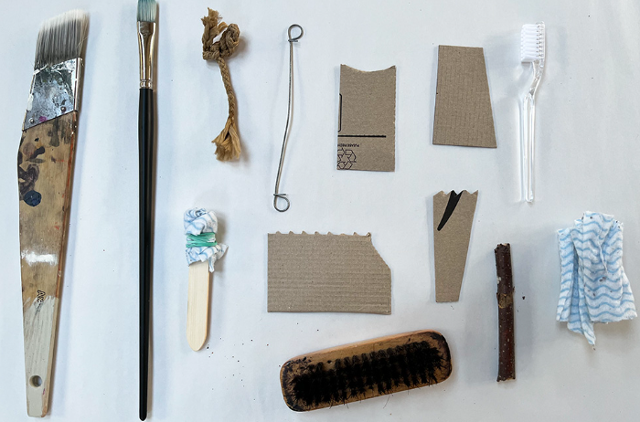 |  | In this session, pupils learn about primary and secondary colours through hands on experience of paint mixing and importantly paint application. They use a variety of made and sourced “tools” to help them apply the paint, layering primary and then secondary colours, and exploring expressive mark making. They start to think about how to use colour and mark making in response to what is already there – a key skill in painting.  Children work on sheets of paper/card (approx A4) and then consolidate the learning by choosing sections of their painted sheets to develop as sketchbook work, helping develop reflection and articulation skills, ready for the next stage of learning. Show children https://www.accessart.org.uk/expressive-painting-colour-mixing/ |  | That they can choose colour and how to make marks, that this is an expression
3 |  | To explore the brush work of Van Gogh & Cezanne |  | Take a close up look at the artists brush work. https://www.accessart.org.uk/talking-points-brush-work-of-van-gogh-cezanne/  Use the questions at the end to help the children to look carefully and share ideas.  Children to use sketch books to make visual notes about brush work and the colours they have seen https://www.accessart.org.uk/visual-notes/  Can they make similar brush marks, they might need to make their own mark making tools, look at https://www.accessart.org.uk/experimental-mark-making-tools/ |  | That they can try out ideas and make visual notes to help them remember
4 |  | To respond to still life forms using continuous line and then collage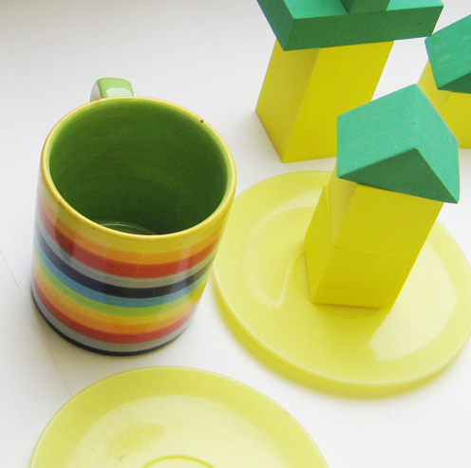 |  | Set up each table with a still life of objects. Colourful objects and plenty to choose from.  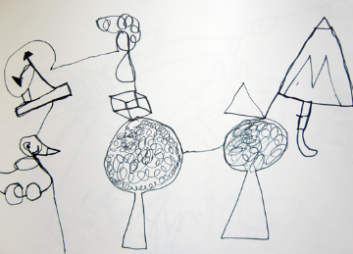  Warm up by doing some continuous line drawing in sketchbooks or on paper. https://www.accessart.org.uk/gestural-mark-making-with-acrylic-paint/  This could be just 10 minutes.  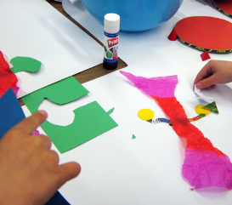  Main part: Collage: the children are still looking at the still life but this time using paper scraps to recreate what they see by cutting, tearing, bending, folding, scrunching. Art might be 2D or 3D. 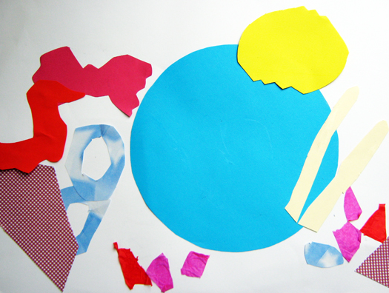
5 |  | To respond to still life with paint  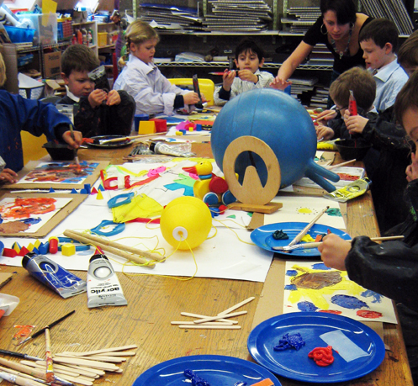 |  | Repeat the still life’s from last week.  This week the aim is to use acrylic paint to represent the objects we can see. Show the utube clips to give them the idea, also remind them of the artists we looked at earlier. Think about what tools you could use  https://www.accessart.org.uk/gestural-mark-making-with-acrylic-paint/  Remind children that we can move the paint around and create layers of paint. Also their artwork might be abstract representation of what they see. The experimentation might take over. Take photos of the process where possible. |  | That they can use paint in a different way
6 |  | To share and reflect on their own and others artwork |  | Time to see the work which has been made, talk about intention and outcome.  Invite children to display the work in a clear space, and walk around the work as if they are in a gallery. Give the work the respect it deserves. Remind the children of their hard work.  If you have class cameras or tablets, invite the children to document their work, working in pairs or teams. Run a class critique..use the resource below to supporthttps://www.accessart.org.uk/crit/ |  | That everyone’s art work can be valued in its own right

