Year Group | Reception
Term | Summer 2
Subject | Art
Topic | Examples of topics: Bees, Science week, Train Ride
Curriculum Intent | To encourage an open-ended exploration of materials, ideas and techniques.  To use an open-ended, child-led approach to help build skills and enjoyment in children so that by the time they enter primary education they have a mindset which will help them become confident, creative learners ready for a more thorough exploration of drawing, making, sketchbooks, painting, printmaking, design and craft.

Key Vocabulary | Pens, pencils, crayons, paint, chalk, colour, mix, water, light, dark, brush, line, detail, shape, glue, scissors.  Create, make, artist, large and small.  Tissue paper, Art Without Glue, collage.

Skills | Fine motor skills - I can use simple tools (scissors, brushes…).  I can use a variety of media, such as paint, glue, pencils, crayons…  I can explore working with paint using objects as “paint brushes”.  I can investigate different lines -thick, thin, wavy, straight…  I can explore shape.  I can observe shape, texture and colour of a natural object.  I can use my hands to transform materials into new things.  I can cut materials with simple tools and fasten materials together to construct my sculpture.  I can collaborate with peers to create a piece of artwork.

Knowledge |  | I know names of primary colours.  I know that colours can be mixed to make new colours.  I know I can work alone or in a small group and then contribute my/our work to shared experience.
Summer 2 MTP Please note the skills and activities might be covered in a different order than as laid out in this medium term plan.
Week | Learning Objective |  | Examples of activities | Differentiation | Outcome
1 | I can use and explore a variety of media, tools and techniques and experiment with texture.  I can select, sort, cut/tear and glue items down. |  | 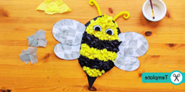 Tissue paper collage. |  | To make a bee collage.
2 | I can make Art without Glue using a variety of natural resources. |  | Transient art – Insects (making insects from natural objects). |  | To produce a piece of transient art.
3 DT | I can select tools and techniques to shape and join materials I am using. |  | 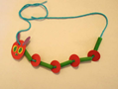 DT – Caterpillar necklace. |  | To make a caterpillar necklace.
4 | I can select, sort, cut/tear and glue items down. |  | 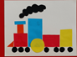 Train shape collage |  | To make a shape collage.
5 | I can explore working with paint on different surfaces and in different ways (e.g. different textured, coloured, sized and shaped paper). |  | 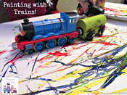 Painting with trains. |  | To create abstract art.
6 | I can select, sort, cut/tear and glue items down. |  | 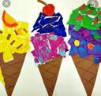 |  | To create a collage.

General learning throughout the year during continuous provision:
• Child-led activities.
• Exploring a range of media throughout the year – pens, pencils, crayons, poster paint, watercolours, wool, textiles and everyday objects.
• Outdoor art using chalk and a range of mark making materials such as paint rollers and different sized brushes on a large scale.
Craft Area enables children to self -select resources that they need / want to test out including masking tape and glue to join.
Carousel – a weekly group sketching/drawing/mark making session – each group accessing this once every half term.

