Year Group | 2
Term | Summer 1
Subject | RE
Topic | Christianity-God
Curriculum Intent | What does it mean if God is holy and loving?

Key Vocabulary | Christians, Christianity, God, The psalms, The bible, creator, shepherd, King, gift-giver, holy

skills | - To listen to viewpoints different from their own  - To ask appropriate and relevant questions  - To share own viewpoints about God and explain them  - To explain what they have learnt from The Psalms

 | Knowledge |  | - That Christians believe God is like a leader or role model  - That we can learn about God from The Psalms  - To make links between the Psalms and what they understand about God  - To explain in own words what they think God is like?  - To make links between their own experiences and what they have learnt about God  - To remember the story of the Creation
Spring 1 MTP
Week |  | Learning Objective |  | Activities | Differentiation | Outcome
1 |  | To know what is God like |  | Think of famous person – how would you describe them? Why are they famous?  The bible tells us what God is like.  What adjectives can you use to describe God?  Children to create an image to show/illustrate these adjectives – on a jigsaw piece. |  | That children can share their understanding of God using words/pictures
2 |  | To know how is God a Creator |  | Think of different things you have created. How does it feel when you make them? How would you feel if it was destroyed?  Listen to the Creation Story from the Bible.  Children to make a bauble/mini book showing Gods Creations. https://christianpreschoolprintables.com/wp-content/uploads/CPP/BibleMinibooks/CreationMinibookPack.pdf  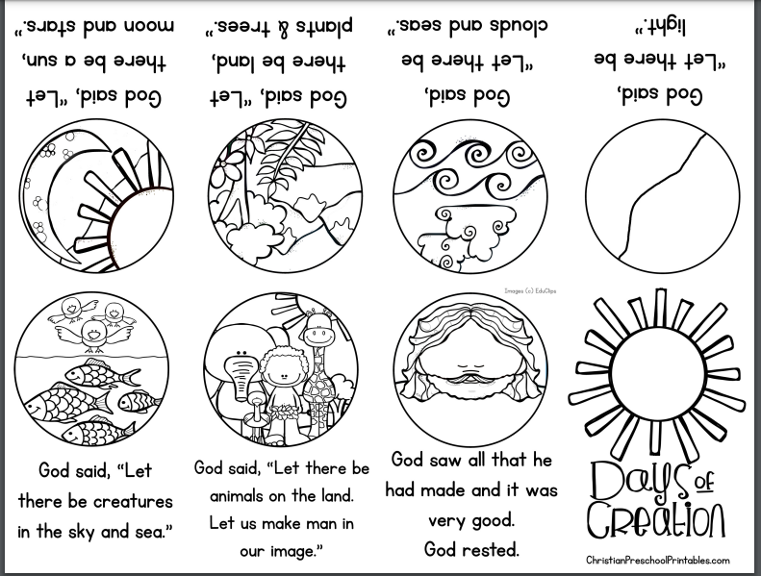 |  | Children can begin to make links between own experiences and God’s role of the ultimate creator
3 |  | To show how God is a King |  | Think about different people who are in charge. How do people behave around them? Look at the Book of Psalms. https://www.youtube.com/watch?v=QwQ5FCJKWz4  Why do you think God is described as a King? What do you think God is King over?  Children use crown template and show with words/pictures what they think God is king over. | 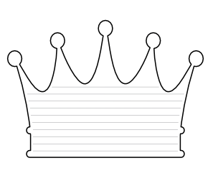 | Children share their ideas about God as a King.
4 |  | To think about how God is a Shepherd to Christians |  | What does a shepherd do? How would you feel if you were a lamb?  Story – The Lord is my Shepherd. https://www.youtube.com/watch?v=g-uOnrrzOh0  Children to think / write their ideas about how God is a shepherd for us? |  | Children can share their ideas about how God cares for his people
5 |  | To think about how is God a Gift-Giver |  | What is the best gift you have received?  Which gifts do you think God has given us? – Physical and spiritual gifts. Why do you think they are important?  Draw some of the gifts that god has given us – and write sentences to explain why God gave them to us. |  | Children can think of gifts which are physical and spiritual
6 |  | To explain in own words what is God like? |  | What have we learnt about God this term? https://www.youtube.com/watch?v=OTf95XLX19g  What different characteristics does he have?  Have your ideas about God changed? Children share their thoughts to add to a class mind map. |  | Children can say what they have learnt about God from The Psalms

