I can spell compound words.
football farmyard bedroom
I can use -ing, -ed, -er and -est where no change is needed to the root word.
helping helper helped quicker quickest

I can name the letters of the alphabet in order.
I can write from memory simple sentences dictated by the teacher, including GPCs and common exception words.

I can spell the days of the week.
Monday, Tuesday, Wednesday, Thursday, Friday, Saturday, Sunday
I can spell words containing the 40+ phonemes already taught.
qu sh ch th ng ai ay a-e oi oy e-e ee ea i-e ie igh o-e oa oe u-e oo ew u ear er ir ur ou ow or aw au ure ore air ear ph wh

I can spell words ending in -y.
happy very funny party family
I can use letter names to distinguish between alternative spellings.

I can use the prefix un- and know how it changes a word.
unhappy unkind unlock untie unpack

I can add -s or -es
cats dogs thanks catches rocks

I can spell words using the /k/ sound.
kit sketch skin Kent kite
Year One
Writing Objectives
I am beginning to use some adjectives.
pretty huge gigantic tall beautiful grumpy annoying
I can spell common exception words.
I no go to into the be we me she he you are her was all they my said have like so do come some little one were there what when out today says your by here where love come some one once ask friend school pull full house our

I can use a capital letter for:
- names of people
- places
- days of the week
- personal pronoun ‘I’
I can use different openers.
then after suddenly luckily quickly later next soon
I can sit correctly at a table.

I can always use finger spaces.
I can hold a pencil comfortably and correctly. 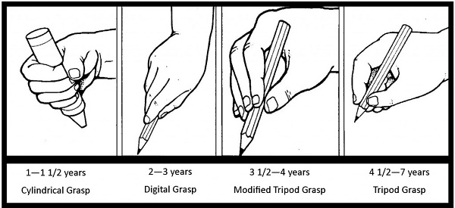

I can form capital letters.
A B C D E F G H I J K L M N O P Q R S T U V W X Y Z

I can write sentences by saying out loud what I want to write.
I am beginning to punctuate sentences using capital letters and full stops.
I can join words and clauses using ‘and’.
I can use and understand the following words when discussing my writing:
- letter - sentence
- capital letter - punctuation
- word - full stop
- singular - question mark
- plural - exclamation mark

I am beginning to punctuate sentences using questions marks and exclamation marks.
I can form digits 0-9.
0 1 2 3 4 5 6 7 8 9

I understand which letters belong to which handwriting family.
c o a g q d s e f x w v z
r n m h p b k l t i j u y

I can discuss what I have written with my teacher and friends.
I can read aloud my work so that it can be heard by my friends and teacher.
I am beginning to form lower case letters correctly.
a b c d e f g h i j k l m n o p q r s t u v w x y z

I can write sentences by re-reading what I have written to check it makes sense.
I can write sentences by composing a sentence orally before writing it.
I can write sentences by sequencing sentences to form short narratives.

